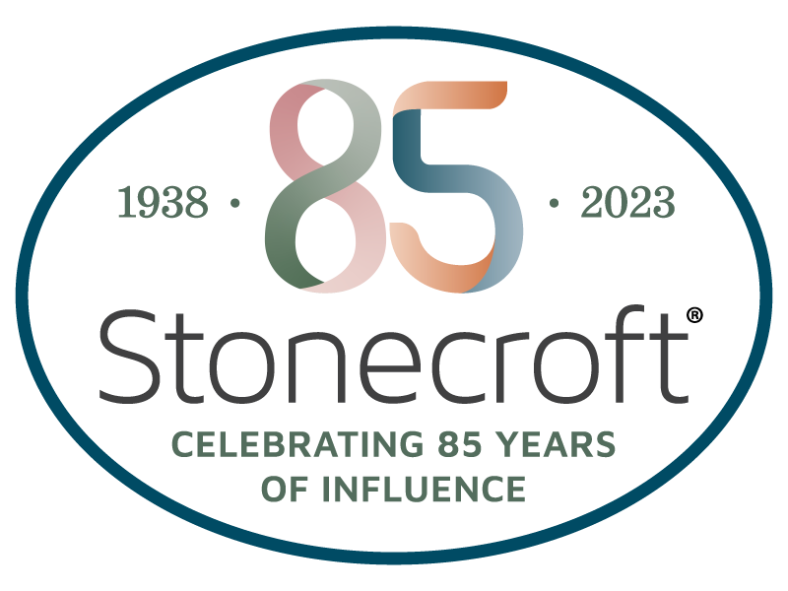
One generation shall commend Your works to another and shall declare Your mighty acts. Psalm 145:4

Yes, I want to leave a Kingdom legacy as a Founding Member through the Stonecroft Legacy Circle as it continues the mission to help women reconcile to God through His Son, Jesus Christ, and live God’s extraordinary through each day of ordinary.

Name: ______________________________________________________________________________________________________

Address: ____________________________________________________________________________________________________

Email: _______________________________________________ Date of Birth: ____________________________________________

Names for Publication: _________________________________________________________________________________________

Founding Members received through 12/31/23. Note: Your minimum commitment of $3,000 qualifies you as a Member of the Stonecroft Legacy Circle.
Type of Provision Estimated Amount

- Will Outright Bequest: Please state the percentage or residual and appropriate amount: $____________________
- Retirement Plan Beneficiary Designation $____________________
- Life Insurance $____________________
  - Policy Type: _______________________________
  - Owner: ___________________________________
- Charitable Gift Annuity $____________________
- Charitable Trust $____________________
  - Remainder: _______________________ or Lead: __________________________
  - Payout Rate: _______________________________
  - Income Beneficiaries Date(s) of Birth: ____________________________________
- Other (Appreciated non-cash assets such as stock, bonds, and real estate) $____________________
  - Please describe: _____________________________________________________
Please designate this Legacy Circle gift to support:
c Greatest Need (provides the maximum flexibility to meet future needs)
c Relational Evangelism c Small Group Resources
Please attach documents which further describe the nature of the above provision(s) in addition to a copy of the section of Will or Trust in which Stonecroft Legacy Circle is mentioned. In the event of unforeseen circumstances which might necessitate further change in the above estate planning provision(s), I will notify the Stonecroft Legacy Circle of such change: ______________ (initials).

Signature: ______________________________________________________________ Date: ____________________________
Thank you for returning this completed form to Stonecroft (address, phone and email below). Stonecroft is a 501(c)(3). Tax ID: 43-6041686 Stonecroft is a 501(c)(3) non-denominational nonprofit organization and a member of the Evangelical Council for Financial Accountability (ECFA). Thank you for your Kingdom Investment!

